CS1980 – Hardware / Software Interface

Deliverable 2 – Midterm Update

Rob Colleran, Eric Hochendoner, Andrew Panzl

POC: Don Bullock

Our team is currently in the early development and design stages of this project. No user stories have been fully implemented but much of the division of labor and general design of the project has been established. Much of our time so far has been spent coming to agreements on work division, user story prioritization, and design aspects. This involved creating documents, including a System Requirements Specification (SRS), System Design Document (SDD), Statement of Work (SOW), and Working Agreement. Creating the SDD, in particular, required us to map out a lot of design aspects (languages, libraries, scope and modules of each software component, etc.) ahead of time.

Some new user stories needed to be added based on new information from our POC. For example, he decided that sockets should be used for any and all communication between the software components. He also specified a few libraries that he wanted us to use. While he typically has avoided specifying implementation details in the past, he felt these were necessary to keep the project on track as we were continually learning about the hardware and how to communicate with it. A few user stories were also removed based on our progress so far. The POC is no longer requiring us to write code to invert the raspberry pi’s wifi adapter and no longer requires the logic engine to accept input of absolute angle locations. These were removed due to time constraints and the fact that they were considered very optional from the start.

Early changes made to user stories were inflicted due to group size. Coming into the project, the client/mentor openly stated that project was intended for a project group of five to eight people. At a current max, there is a working group of three. To better accommodate a smaller group size, certain roles were eliminated and others combined to evenly distribute the work load. This was done successfully however it also meant eliminating avoidable tasks. The roles shown in <Figure A. > are the resulting roles: hardware, software, and web interface.

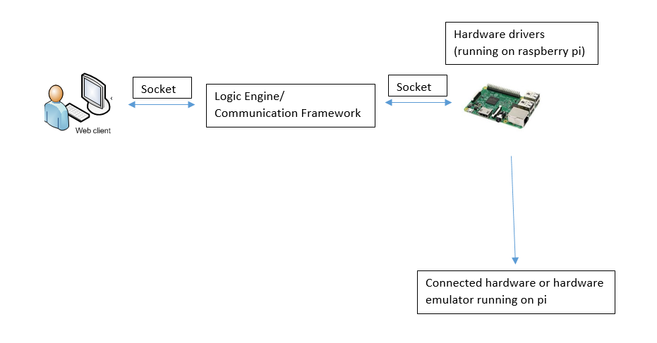  
Figure A: System Design Diagram

As previously stated, a few user stories were also removed based on our progress so far. Some, three or four, weeks into the project, these changes were made to accommodate a slower than anticipated project pace. On a week-to-week basis, the mentor is clear to state expectations and goals for the next weekly meeting. This has been one of the more positive aspects of the project. To the current milestone, the majority of expectations have been to understand the professional engagements surrounding the project. These expectations include the documents listed, programmatic libraries intended to be used during development, and specific hardware features. Our team does feel that we could accomplish more and meet higher expectations than the ones set so far, so a quicker pace should hopefully be set for the future.

The slow pace so far may be attributable to the steep learning curve for this project. None of the team members have prior experience with the rigorous level of documentation required by the client. Because of this, our pace should quicken as we move into the far more familiar realm of software implementation.

Additionally, another positive aspect to date has been open communication at all times. Never has the mentor been inaccessible, nor have any team members been unreachable. As a result, all expectations were met clearly and on time. Our regular weekly meetings have been invaluable in ensuring that all team members were on the right track